

Prabhat Kumar Sinha

t|

Performance Specialis

I'm an

# 

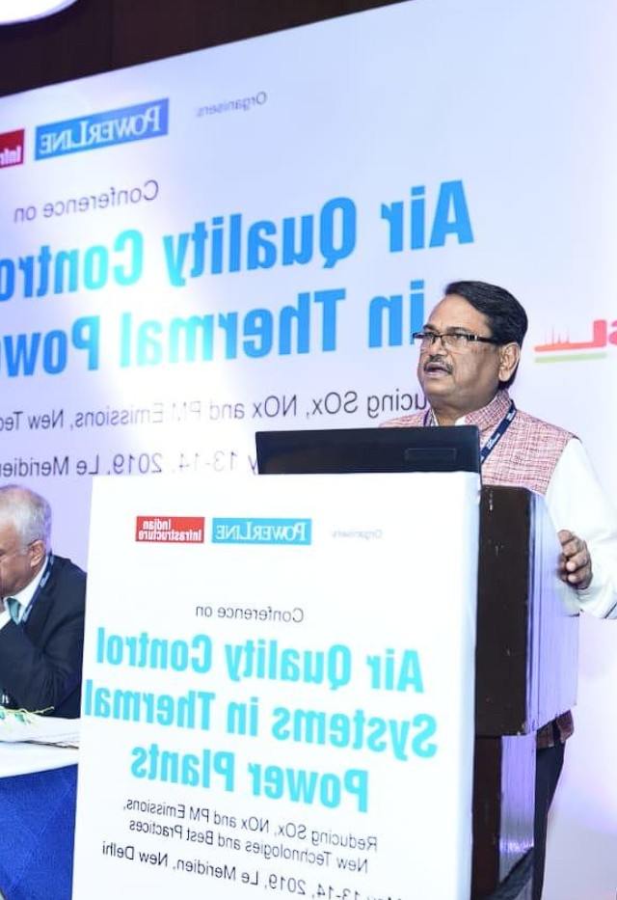

Performance Optimization



Leadership & Training



Safety & Complia





**ABOUT ~~PRABHAT KUMAR SINHA~~  ME**

**Independent Consultant & Trainer in the ~~Power~~ Power Generation Sector**

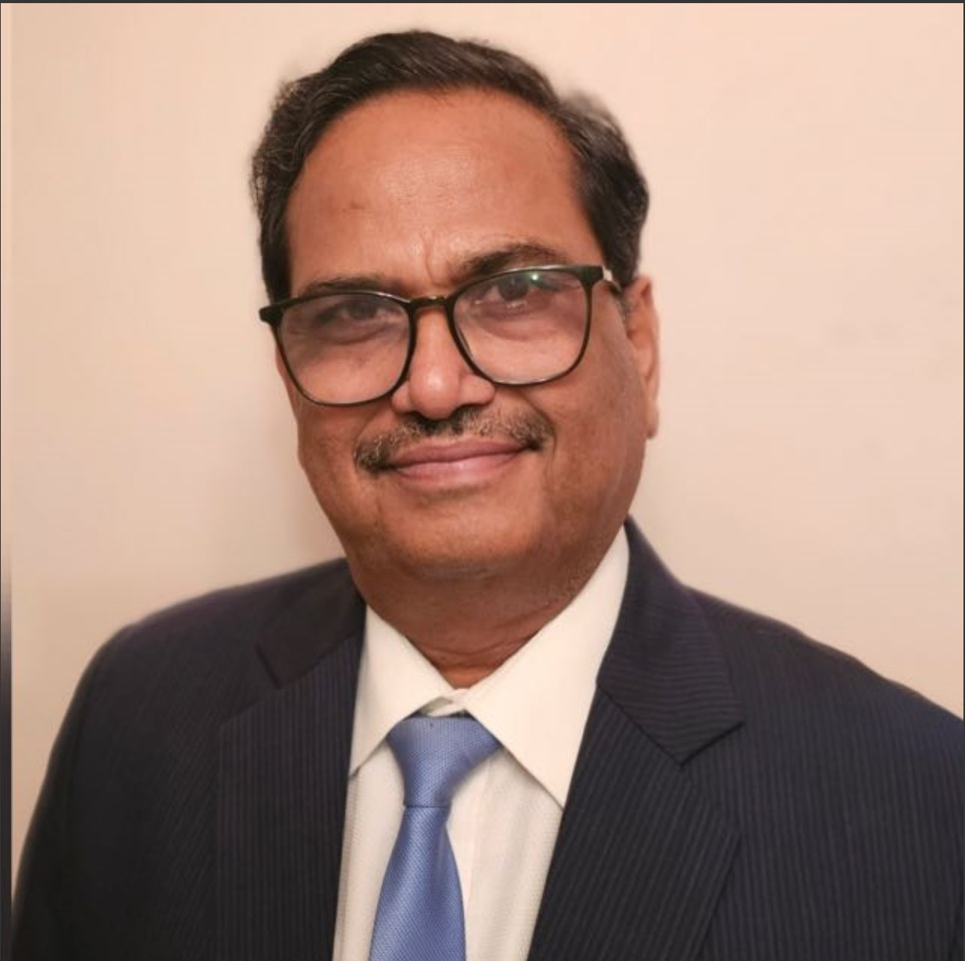

*As an independent consultant and trainer I undertake and resolve the challenges arising in competitive power generations, addition of renewables, cyclic operations, EHS management and up-skilling of the operational teams*

*With over 40 years of extensive experience in the power generation sector, I specialize in strategic asset management for operational excellence and sustained growth of the organizations in the energy sector and allied industries.*

*I worked for 36 years at NTPC and its joint ventures NASL/NGSL , where I held diverse leadership roles across project management, operations and maintenance (O&M), and renovation and modernization (R&M) and EHS..*

Currently, I continue to deliver consultancy and training services to prominent organizations in the energy sector, including NTPC, JP Power, Vedanta Power, and global consultancies like BCG, GLG, KLINE, INSIGHT ALPHA, and Accenture. I associated with leading Institutes like NTPC-PMI, BIMTECH and XIME for up-skilling the management teams.

My commitment is to enable organizations to achieve operational excellence and sustainable growth through continuous adoption of industry best practices and up-skilling of the operational team.

Contact Me

 **25+**

**Consulting Projects** Executed Globally & in India

 **50+**

**Power Plant Optimizations** Led Major Thermal Power Plant Projects

 **4000+**

**Hours of Consultancy** In Performance Improvement & Training

 **200+**

**Professionals Trained** In Technical & Management Programs

### 



**WORK EXPERIENCE**

Power sector leader with 30+ years of experience in strategic management, performance optimization, and business development across major power plants.

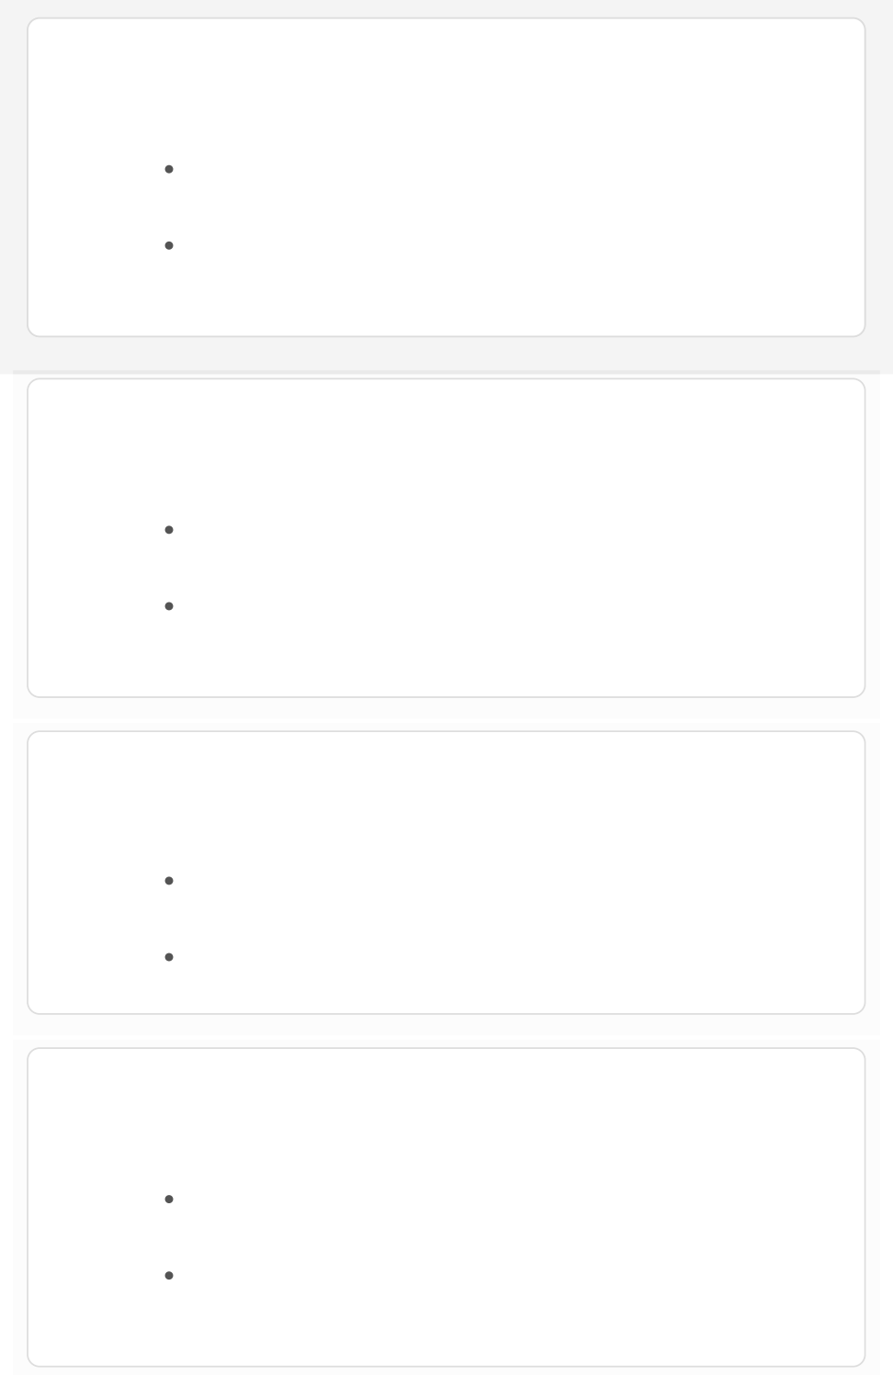



Independent Consultant / Advisor

*Consultancy Houses & Power Utilities*

Consultancy on strategic management and performance improvements.

Recent Projects: Vedanta Power , JP Power (2x800 MW), Hiranmaya Energy (2x150 MW).



Executive Director

*NTPC*

Led corporate initiatives in environment management, safety, and sustainability.

Managed regulatory compliance and government body relations.



Whole Time Director

*NASL (Now NGSL – JV of NTPC & GE)*

Directed P&L, revenue growth, and project execution for power plants (up to 660 MW).

Led plant upgrades and performance enhancements of cumulative value of more than 1000 Cr



CEO

*KBUNL (JV of NTPC & BSPCL)*

Oversaw 640 MW( 2x195+ 2x110 ) power plant operations, business growth, and stakeholder relations.

Managed credit ratings improvement and vendor negotiations.

### 





Leadership Roles in O&M

*NTPC (Vindhyachal & Farakka)*

Led turbine overhauls (210 & 500 MW), major commissioning & maintenance activities.

Presented papers at FICCI and national symposia on steam turbine O&M.

## SERVICES

Offering a range of consulting and training services focused on performance improvement, strategic management, and technical expertise in the power sector.

**Performance Improvement Consulting**



Expertise in identifying performance gaps and optimizing the efficiency of thermal power plants, reducing downtime and boosting productivity.

**Strategic Gap Analysis**



Comprehensive analysis of aging power plants to develop strategies for performance improvement and extending operational lifetimes.

**Operations & Maintenance Support**



Assistance with major overhauls, steam turbine troubleshooting, and the implementation of maintenance optimization techniques.

**EHS Audits & Training**



Specialized training and audit services for Environment, Health, and Safety (EHS) compliance in power plants and industrial setups.

**Technical & Management Training**



### 

Upskilling power sector professionals through specialized technical

and management programs tailored to the needs of power utilities. 

**Sustainability & Ash Management**



Leadership in sustainability initiatives, including innovative solutions for ash management and environmental compliance in power plants.

## PORTFOLIO

A showcase of key projects and consulting assignments that demonstrate expertise in power sector performance improvement, gap analysis, and strategic management.

ALL CONSULTING PROJECTS POWER PLANT OPTIMIZATIONS

TRAINING & WORKSHOPS

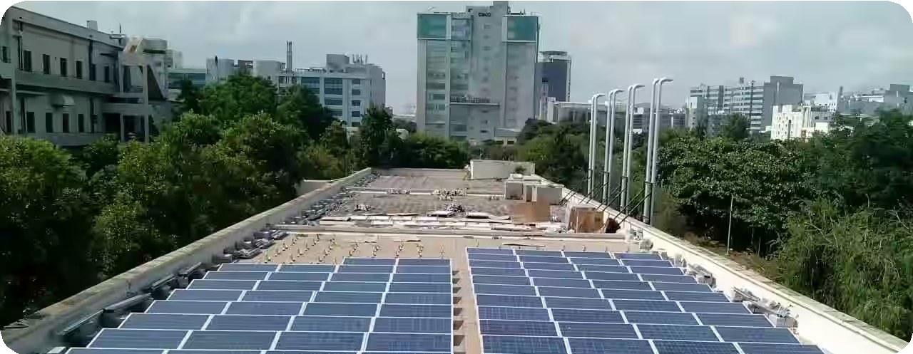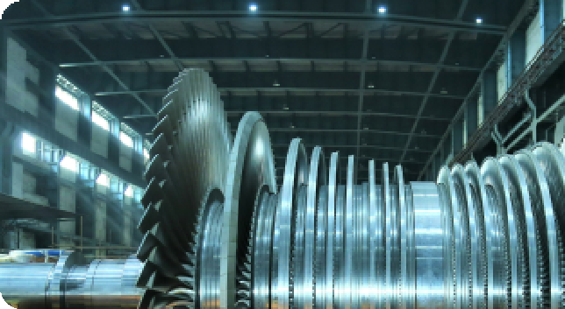

**Performance Assessment for JP PoCwoenr,sNuligtarni cy on Unit 2 TurBbien**

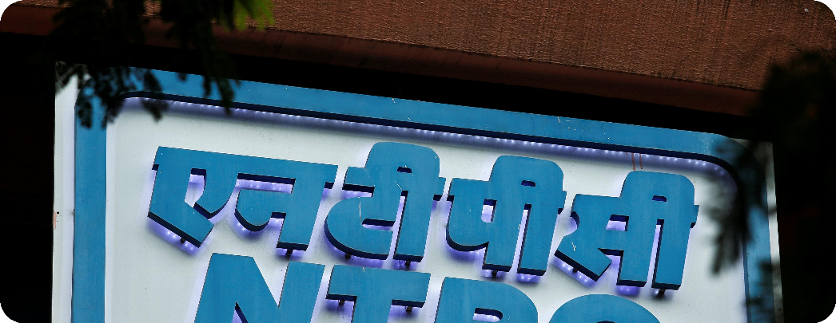

**Flexibilization Measures SanfdetRyeMtraon atsgement Workshop foSrt**

### 



## COMPANIES WORKED WITH

A selection of leading companies Prabhat Kumar Sinha has collaborated with during his extensive career in the power sector.



## RECENT WORKS

A showcase of Prabhat Kumar Sinhaʼs latest contributions, insights, and key industry posts, highlighting his leadership and innovation in the power sector.





**PowerUp Masterclass Series**

Prabhat Sinha shares insights on Steam Turbine Distress Signals and

Troubleshooting. A must-watch for industry professionals.

[**View Post on LinkedIn** ](https://www.linkedin.com/posts/prabhat-sinha-09303112_know-it-all-about-the-powerup-masterclass-activity-7109432898016935936-qg-_?utm_source=share&utm_medium=member_desktop)

# 



**Consulting Project: JP Power Nigri (2x800 MW)**

Prabhat Sinha led a project to optimize steam turbine performance at JP Power, Nigri, delivering a 10% efficiency boost.

# 

**Leadership in Energy Management**

Learn about Prabhat Sinhaʼs approach to improving operational efficiency and leadership in large-scale energy projects.

[**View Post on LinkedIn** ](https://www.linkedin.com/post-url-2)

# 

**Research Paper: Enhancing Power Plant E ciency**

This research paper outlines Prabhat Sinhaʼs contributions to enhancing steam turbine performance in aging power plants.

**View Paper** 

# 

**Keynote: Energy Transition in India**

Prabhat Sinha delivered a keynote speech on India's energy transition roadmap and strategies for sustainable development.

**Learn More** 

 



**Sustainability: Ash Management at NTPC**

Prabhat Sinha led a sustainability initiative at NTPC, reducing environmental impact by 15% through innovative ash management.

**TESTIMONIALS**

Hear from professionals in the power sector about Prabhat's leadership and expertise in project management, performance improvement, and turbine engineering.

 *Prabhat worked with me as part of the senior management team at NTPC Alstom Power Services (Pvt)*

*Ltd****.*** *As Head of Project Management****,*** *he skillfully managed high-pressure environments while keeping clear focus on technical and commercial deliverables****.*** *His enthusiasm and leadership kept the team motivated and ensured successful execution*

*of complex projects****.***



 *Mr****.*** *PK Sinha is an excellent turbine engine with in-depth knowledge turbine design****,*** *maintena*

*and performance improvement****.*** *He effectiv*

*managed several R&M contracts****,*** *achieving bett than-guaranteed perform within costs and schedul His expertise makes him exceptional leader in an*

*power sector organizati*



 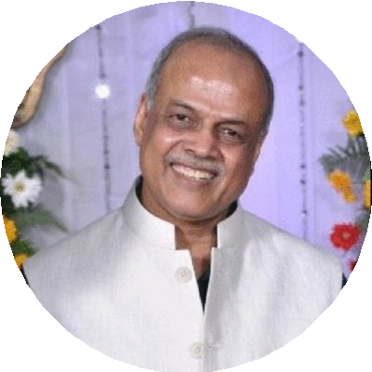

**Martin Seamer**

Managing Partner at Konexus Global Consulting

**Dinesh Kumar Jain**

Advisor/Consultant in Power Ge

Industry

### 



## CONTACT

Please feel free to reach out for any inquiries or discussions.

### 

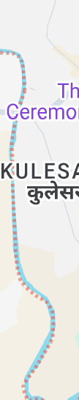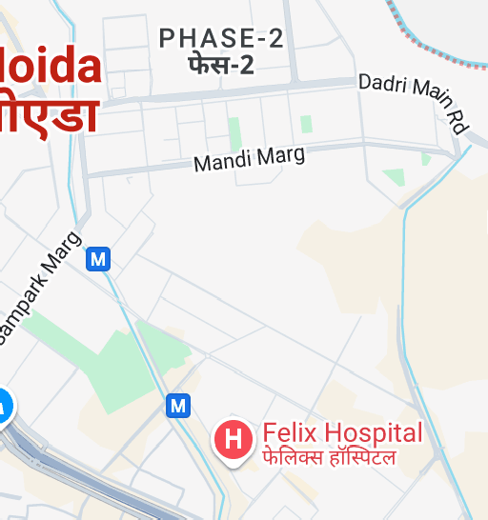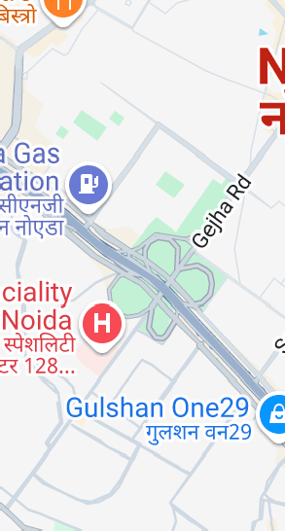

Noida

Uttar Pradesh, India

Directions

[View larger map](https://maps.google.com/maps?ll=28.522202%2C77.401825&z=13&t=m&hl=en&gl=US&mapclient=embed&q=Noida%20Uttar%20Pradesh%20India)

**Address**



Noida, India

**Call Me**



+91 9810737311 / +91 9650049404

**Email Me**



[sinhapk359@gmail.com](mailto:sinhapk359@gmail.com)

Map data ©2024 [Report a map error](https://www.google.com/maps/%4028.5222018%2C77.4018255%2C13z/data%3D!10m1!1e1!12b1?source=apiv3&rapsrc=apiv3)

Your Name

Your Email

Subject



Message

Send Message

© Copyright **Made by Ayush** All Rights Reserved

### 